Social Media Project
Problem Statement
You are hired as a data analyst at Meta and asked to collaborate with Marketing team. Marketing teams wants to leverage Instagram's user data to develop targeted marketing strategies that will increase user engagement, retention, and acquisition. Provide insights and recommendations to address the following objectives.
Objective questions
- Are there any tables with duplicate or missing null values? If so, how would you handle them?
- No, there are no tables with missing null values or duplicate values.
- If there are null values, then they can be filled or removed based on the extent of data present. If there is only one column which has null values, then it could be filled with NA as we have the other columns. But if multiple columns have null values, then it could be removed.
- If there are duplicate values, then they could be simply removed after keeping the most recent value.
- What is the distribution of user activity levels (e.g., number of posts, likes, comments) across the user base?
- The users could be divided into various activity levels based on their interaction (number of posts, likes, comments) on social media.
- I am using the below formula to determine the activity score:
activity_score = (weight_post × number_of_posts)
+ (weight_like × number_of_likes)
+ (weight_comment × number_of_comments)
  - weight_post, weight_like and weight_comment are the weightage of each, i.e., weightage of a post is 3 as original content is most valuable, weightage of comments is 2 as it indicates meaningful interaction and weightage of likes is 1 as it takes least effort, but still shows engagement.
- After determining the activity score of each user, they can be classified into four activity levels based on their activity score.
Activity Level | Score Range
Highly Active | > 400
Moderately Active | 201–400
Low Activity | 1–200
Inactive | 0

After running the below query, we found that there are 13 highly active users, 64 moderately active users ,10 low active user and 13 inactive users.

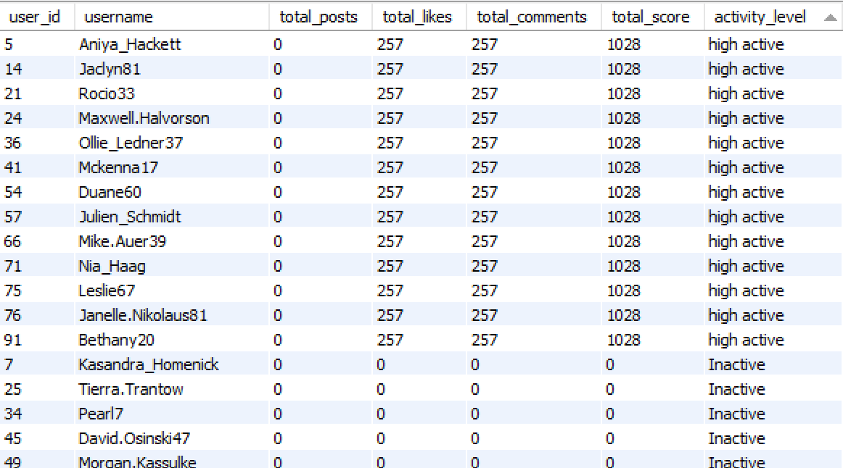

- Query-

with activity_events as (
select user_id,1 as points from likes
union all
select user_id,3 as points from comments
union all
select user_id,5 as points from photos
),
user_activity as (
select u.id as user_id ,u.username,
coalesce(sum(points) over(partition by u.id),0) as total_score,
sum(case when points=1 then 1 else 0 end) over(partition by u.id) as total_likes,
sum(case when points=3 then 1 else 0 end) over(partition by u.id) as total_comments,
sum(case when points=5 then 1 else 0 end) over(partition by u.id) as total_posts
from users u
left join activity_events ae
on u.id=ae.user_id ),
final_user_activity as (
select distinct
user_id,
username, total_posts, total_likes,
total_comments, total_score
from user_activity)
select *,
case
when total_score = 0 then "Inactive"
when total_score between 1 and 200 then "Low active"
when total_score between 201 and 400 then "moderate active"
else "high active"
end as activity_level
from final_user_activity;

- Calculate the average number of tags per post (photo_tags and photos tables).
- The average number of tags per post is 1.9494
- This can be determined by dividing number of tags by number of photos.
- Hence, I used the below query to determine the same.
- Query-
select
count(t.tag_id)/ count(distinct p.id) as avg_tags_per_post
from photos p
left join photo_tags t on p.id = t.photo_id;

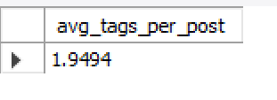

- Identify the top users with the highest engagement rates (likes, comments) on their posts and rank them.

- Calculated the engagement rate per post using the below formula:
engagement_rate = number of likes + number of comments
- Calculated the number of likes and comments for each post and then used the sum function to add both as per the formula.
- Used rank function to rank the users and their posts based on the engagement_rate.

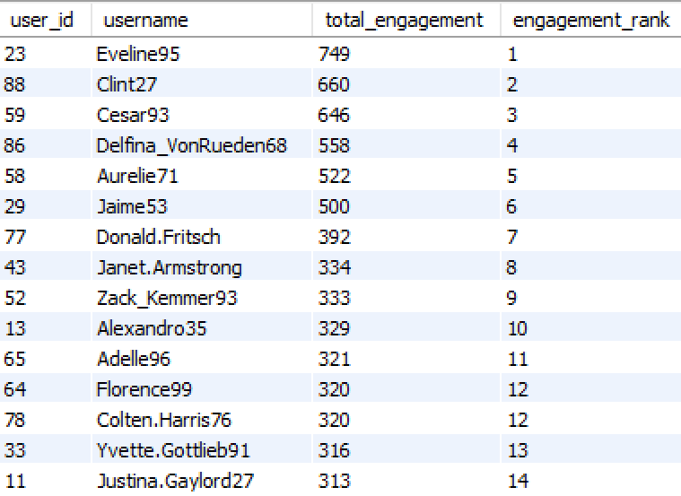

- Query-
with num_comments as (
select photo_id,count(*) as num_of_comments
from comments
group by photo_id ),
num_likes as (
select photo_id,count(*) as num_of_likes
from likes
group by photo_id ),
photo_engagement as (
select p.id as photo_id,
p.user_id,
coalesce(c.num_of_comments,0)+coalesce(l.num_of_likes,0) as engagement
from photos p
left join num_comments c
on c.photo_id=p.id
left join num_likes l
on l.photo_id=p.id ),
user_engagement as (
select user_id,
sum(engagement) as total_engagement
from photo_engagement
group by user_id
)
select ur.user_id, u.username, ur.total_engagement,
dense_rank() over(order by total_engagement desc) as engagement_rank
from users u
join user_engagement ur
on u.id=ur.user_id
order by ur.total_engagement desc limit 15;

- Which users have the highest number of followers and followings?

- Used CTE to store the number of followers and followings.
- The users having highest number of followers and followings:

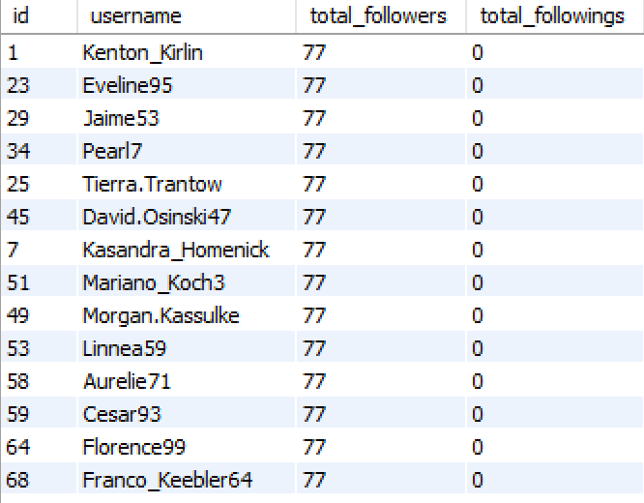

- Query-
with follower_count as (
select followee_id as user_id,
count(*) as followers
from follows
group by followee_id
),
following_count as (
select follower_id as user_id,
count(*) as followings
from follows
group by follower_id
)

select u.id,
u.username,
coalesce(f.followers,0) as total_followers,
coalesce(fl.followings,0) as total_followings
from users u
left join follower_count f
on u.id=f.user_id
left join following_count fl
on u.id=fl.user_id
order by total_followers desc,total_followings desc;

- Calculate the average engagement rate (likes, comments) per post for each user.

- Calculated the engagement rate per post using the below formula:
engagement rate = number of likes + number of comments
- Calculated the number of likes and comments for each post and then used the sum function to add both as per the formula.
- Used average function to find the average engagement rate for each user.
- Average engagement rate of each user:
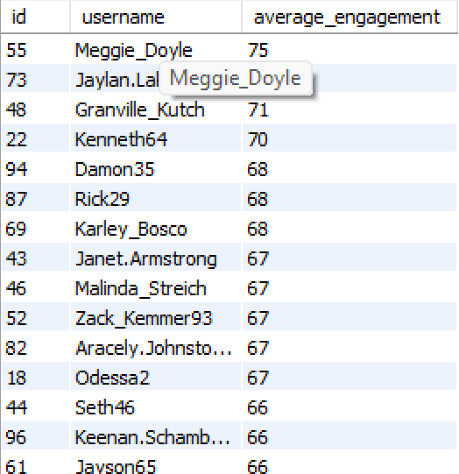
- Query
with num_comments as (
select photo_id,count(*) as num_of_comments
from comments
group by photo_id
),
num_likes as (
select photo_id,count(*) as num_of_likes
from likes
group by photo_id
),
photo_engagement as (
select p.id as photo_id,
p.user_id,
coalesce(c.num_of_comments,0)+coalesce(l.num_of_likes,0) as engagement
from photos p
left join num_comments c
on c.photo_id=p.id
left join num_likes l
on l.photo_id=p.id
)
select u.id,
u.username,
round(avg(engagement),0) as average_engagement
from users u
join photo_engagement pe
on u.id=pe.user_id
group by u.id
order by average_engagement desc;
- Get the list of users who have never liked any post (users and likes tables)

  - Users who are not present in the likes table are the users who have never liked a post.
  - So used a simple subquery to determine the below result:
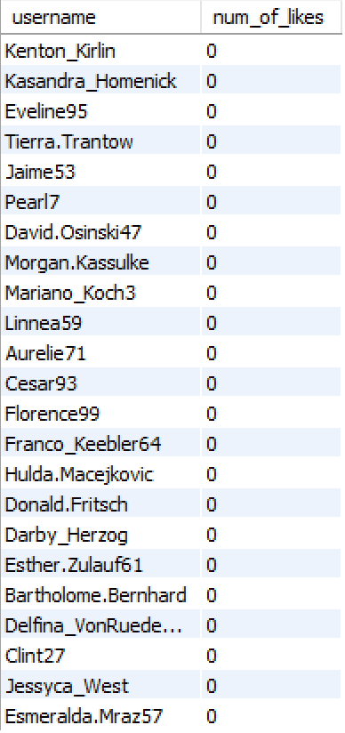

  - Query
select u.username,count(l.photo_id) as num_of_likes
from users u
left join likes l
on u.id=l.user_id
where l.photo_id is null
group by u.username;
- How can you leverage user-generated content (posts, hashtags, photo tags) to create more personalized and engaging ad campaigns?

- Analyze hashtags and photo tags to identify users’ interests, locations, events, or product preferences.
- Group users based on recurring themes — e.g., fitness, fashion, travel — to target them with highly relevant ads.
- Track who interacts with specific user generated content (likes, shares, comments), and build retargeting lists.
- Serve ads to users who have already shown interest in certain categories or influencers.

--Query
SELECT
t.tag_name,
COUNT(l.photo_id) AS total_likes
FROM tags t
JOIN photo_tags pt
ON t.id = pt.tag_id
JOIN photos p
ON pt.photo_id = p.id
LEFT JOIN likes l
ON p.id = l.photo_id
GROUP BY t.tag_name
ORDER BY total_likes DESC;
- Are there any correlations between user activity levels and specific content types (e.g., photos, videos, reels)? How can this information guide content creation and curation strategies?

  - I assigned different weightages to posts, comments, and likes based on the level of effort and value each action contributes to the platform.
  - Posts (weight = 3): Creating original content requires the highest effort and provides the most value to the platform. Users who post frequently are actively contributing to the ecosystem, shaping discovery and engagement.
  - Comments (weight = 2): Commenting indicates meaningful interaction. It requires more effort than simply liking a post and reflects a deeper level of engagement — expressing opinions, appreciation, or emotions.
  - Likes (weight = 1): Likes require the least effort but still represent engagement. They help signal content relevance and preference, but are weighted lower compared to posts and comments.
  - Using these weights, the activity score directly correlates with how much effort and value each user contributes to the platform.
--Query
WITH activity_events AS (
-- Like = 1 point
SELECT user_id, 1 AS points FROM likes
UNION ALL
-- Comment = 3 points
SELECT user_id, 3 AS points FROM comments
UNION ALL
-- Post = 5 points
SELECT user_id, 5 AS points FROM photos
),

user_activity AS (
SELECT u.id AS user_id,
COALESCE(SUM(points), 0) AS total_activity_score
FROM users u
LEFT JOIN activity_events ae
ON u.id = ae.user_id
GROUP BY u.id ),

activity_level AS (
SELECT
user_id,
CASE
WHEN total_activity_score = 0 THEN 'Inactive'
WHEN total_activity_score BETWEEN 1 AND 200 THEN 'Low Activity'
WHEN total_activity_score BETWEEN 201 AND 400 THEN 'Moderate Activity'
ELSE 'High Activity'
END AS activity_level
FROM user_activity
),

photo_engagement AS (
SELECT
p.id AS photo_id,
p.user_id,
COUNT(DISTINCT l.user_id) + COUNT(DISTINCT c.id) AS engagement
FROM photos p
LEFT JOIN likes l ON p.id = l.photo_id
LEFT JOIN comments c ON p.id = c.photo_id
GROUP BY p.id, p.user_id
),

photo_topics AS (
SELECT
pe.photo_id,
pe.user_id,
t.tag_name,
pe.engagement
FROM photo_engagement pe
JOIN photo_tags pt ON pe.photo_id = pt.photo_id
JOIN tags t ON pt.tag_id = t.id
)

SELECT
al.activity_level,
pt.tag_name,
ROUND(AVG(pt.engagement), 2) AS avg_engagement,
COUNT(DISTINCT pt.photo_id) AS total_posts
FROM activity_level al
JOIN photo_topics pt
ON al.user_id = pt.user_id
GROUP BY al.activity_level, pt.tag_name
ORDER BY al.activity_level, avg_engagement DESC;

activity_level AS (
SELECT
user_id,
CASE
WHEN total_activity_score = 0 THEN 'Inactive'
WHEN total_activity_score BETWEEN 1 AND 200 THEN 'Low Activity'
WHEN total_activity_score BETWEEN 201 AND 400 THEN 'Moderate Activity'
ELSE 'High Activity'
END AS activity_level
FROM user_activity
),

photo_engagement AS (
SELECT
p.id AS photo_id,
p.user_id,
COUNT(DISTINCT l.user_id) + COUNT(DISTINCT c.id) AS engagement
FROM photos p
LEFT JOIN likes l ON p.id = l.photo_id
LEFT JOIN comments c ON p.id = c.photo_id
GROUP BY p.id, p.user_id
),

photo_topics AS (
SELECT
pe.photo_id,
pe.user_id,
t.tag_name,
pe.engagement
FROM photo_engagement pe
JOIN photo_tags pt ON pe.photo_id = pt.photo_id
JOIN tags t ON pt.tag_id = t.id
)

SELECT
al.activity_level,
pt.tag_name,
ROUND(AVG(pt.engagement), 2) AS avg_engagement,
COUNT(DISTINCT pt.photo_id) AS total_posts
FROM activity_level al
JOIN photo_topics pt
ON al.user_id = pt.user_id
GROUP BY al.activity_level, pt.tag_name
ORDER BY al.activity_level, avg_engagement DESC;

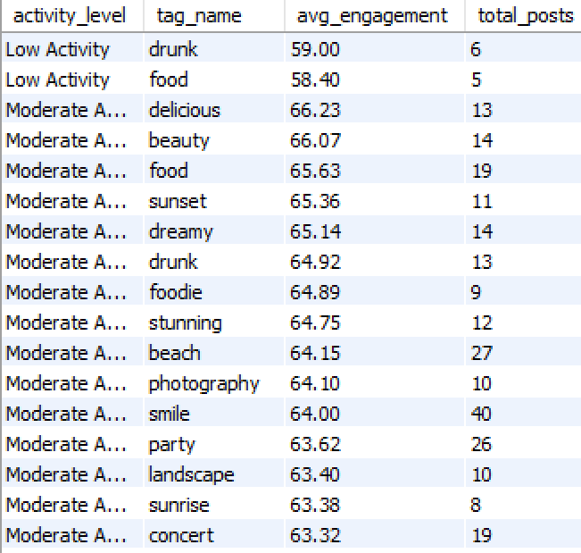
- Calculate the total number of likes, comments, and photo tags for each user

- Calculated the number of likes, comments and photo tags for each user individually using Common Table Expression (CTE).
- Then joined all the CTEs with the users table to show the number of likes, comments, and photo tags for each user.
- Result:
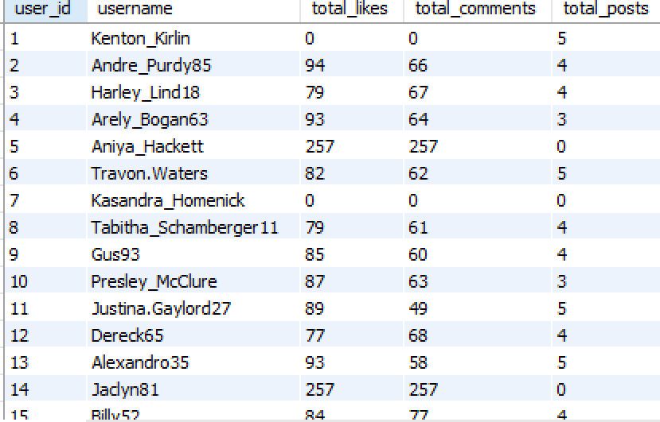
- Query--
with activity_events as (
select user_id,'like' as points from likes
union all
select user_id,'comment' as points from comments
union all
select user_id,'post' as points from photos
),
user_activity as (
select
u.id as user_id,
u.username,
sum(case when points='like' then 1 else 0 end) over(partition by u.id) as total_likes,
sum(case when points='comment' then 1 else 0 end) over(partition by u.id) as total_comments,
sum(case when points='post' then 1 else 0 end) over(partition by u.id) as total_posts
from users u
left join activity_events ae
on u.id=ae.user_id
)
select distinct user_id,
username,
total_likes,
total_comments,
total_posts
from user_activity;

- Rank users based on their total engagement (likes, comments, shares) over a month.

- Calculated the engagement rate per post using the below formula:
engagement_rate = number of likes + number of comments
- Calculated the number of likes and comments for each post and then used the sum function to add both as per the formula.
- Filtered the data for photos created between “2025-12-01” and “2025-12-31”.ie., for the month of December 2025
- Used dense rank function to rank the users and their posts based on the engagement_rate and used limit to display the top users.
- Result:

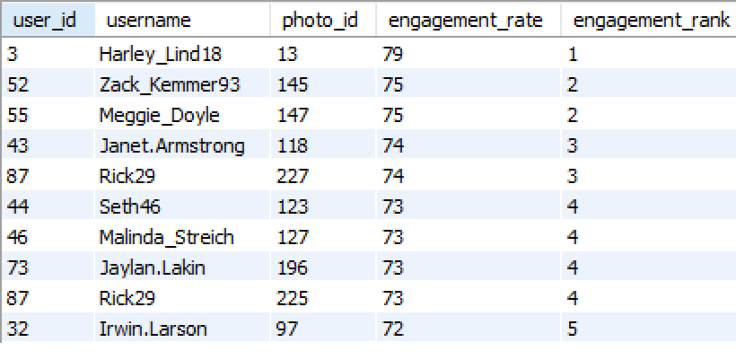

WITH num_likes AS (
SELECT photo_id, COUNT(*) AS num_of_likes
FROM likes
GROUP BY photo_id
),
num_comments AS (
SELECT photo_id, COUNT(*) AS num_of_comments
FROM comments
GROUP BY photo_id),

photo_engagement AS (
SELECT
p.id AS photo_id,
p.user_id,
COALESCE(nl.num_of_likes, 0) + COALESCE(nc.num_of_comments, 0) AS engagement_rate
FROM photos p
LEFT JOIN num_likes nl ON p.id = nl.photo_id
LEFT JOIN num_comments nc ON p.id = nc.photo_id
WHERE p.created_dat BETWEEN '2025-12-01' AND '2025-12-30'
),

ranked_engagement AS (
SELECT
pe.user_id,
u.username,
pe.photo_id,
pe.engagement_rate,
DENSE_RANK() OVER (ORDER BY pe.engagement_rate DESC) AS engagement_rank
FROM photo_engagement pe
JOIN users u ON u.id = pe.user_id
)

SELECT *
FROM ranked_engagement
ORDER BY engagement_rank, engagement_rate DESC
LIMIT 10;

photo_engagement AS (
SELECT
p.id AS photo_id,
p.user_id,
COALESCE(nl.num_of_likes, 0) + COALESCE(nc.num_of_comments, 0) AS engagement_rate
FROM photos p
LEFT JOIN num_likes nl ON p.id = nl.photo_id
LEFT JOIN num_comments nc ON p.id = nc.photo_id
WHERE p.created_dat BETWEEN '2025-12-01' AND '2025-12-30'
),

ranked_engagement AS (
SELECT
pe.user_id,
u.username,
pe.photo_id,
pe.engagement_rate,
DENSE_RANK() OVER (ORDER BY pe.engagement_rate DESC) AS engagement_rank
FROM photo_engagement pe
JOIN users u ON u.id = pe.user_id
)

SELECT *
FROM ranked_engagement
ORDER BY engagement_rank, engagement_rate DESC
LIMIT 10;

- Retrieve the hashtags that have been used in posts with the highest average number of likes. Use a CTE to calculate the average likes for each hashtag first.

- Used a CTE to find the number of likes for each hashtag on all the photos.
- Filtered the hashtags to get only those hashtags whose likes are more than the average number of likes for hashtags.
- Result:

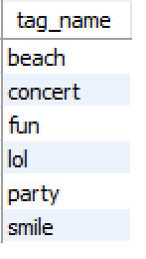

- Query--
with like_tags as (
select p.tag_id, count(l.photo_id) as likes_count
from photo_tags p
left join likes l
on p.photo_id=l.photo_id
group by p.tag_id),
greater_avg_tags as (
select tag_id,likes_count
from like_tags
where likes_count >(select avg(coalesce(likes_count,0)) from like_tags)
)
select t.tag_name from tags t
join greater_avg_tags g on t.id=g.tag_id;

- Retrieve the users who have started following someone after being followed by that person

- There is no output in this case as the created_at is the same for all the followers and followee.
- But, the query in any case would be this:
- Query:
select
b.follower_id as user_who_followed_back,
b.followee_id as original_follower,
a.created_at as followed_first_at,
b.created_at as followed_back_at
from follows a
join follows b
on a.follower_id = b.followee_id
and a.followee_id = b.follower_id
where b.created_at > a.created_at;

Objective questions

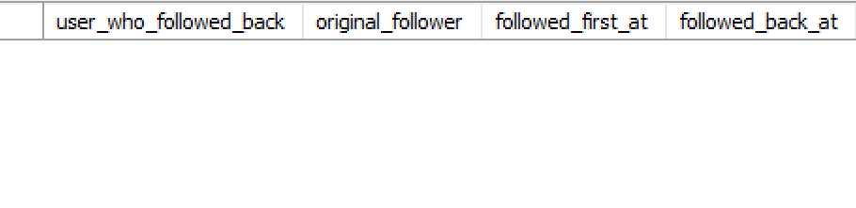

Subjective questions
- Based on user engagement and activity levels, which users would you consider the most loyal or valuable? How would you reward or incentivize these users?

- The users could be divided into various activity levels based on their interaction (number of posts, likes, comments) on social media.
- I am using the below formula to determine the activity score:
activity_score = (weight_post × number_of_posts)
+ (weight_like × number_of_likes)
+ (weight_comment × number_of_comments)
  - weight_post, weight_like and weight_comment are the weightage of each, i.e., weightage of a post is 3 as original content is most valuable, weightage of comments is 2 as it indicates meaningful interaction and weightage of likes is 1 as it takes least effort, but still shows engagement.
- After determining the activity score of each user, they can be classified into four activity levels based on their activity score.

Activity Level | Score Range
Highly Active | > 400
Moderately Active | 201–400
Low Activity | 1–200
Inactive | 0

After running the below query, we found that there are 13 highly active users, 64 moderately active users ,10 low active user and 13 inactive users.

- Query--
with activity_events as (
select user_id,1 as points from likes
union all
select user_id,3 as points from comments
union all
select user_id,5 as points from photos
),
user_activity as (
select u.id as user_id ,u.username,
coalesce(sum(points) over(partition by u.id),0) as total_score,
sum(case when points=1 then 1 else 0 end) over(partition by u.id) as total_likes,
sum(case when points=3 then 1 else 0 end) over(partition by u.id) as total_comments,
sum(case when points=5 then 1 else 0 end) over(partition by u.id) as total_posts
from users u
left join activity_events ae
on u.id=ae.user_id ),
final_user_activity as (
select distinct
user_id,
username, total_posts, total_likes,
total_comments, total_score
from user_activity)
select *,
case
when total_score = 0 then "Inactive"
when total_score between 1 and 200 then "Low active"
when total_score between 201 and 400 then "moderate active"
else "high active"
end as activity_level
from final_user_activity;

Suggestions:
- We can reward active users through incentives like badges, exclusive features, or even early access programs
- We can provide them discount codes, feature shoutouts, leaderboard placement, increased visibility.

- For inactive users, what strategies would you recommend to re-engage them and encourage them to start posting or engaging again?
Approach:

- In the previous query, we determined the highly active, moderately active, and inactive users.
- Calculated the activity score of each user using a pre-defined formula:
activity_score = (weight_post × number_of_posts)
+ (weight_like × number_of_likes)
+ (weight_comment × number_of_comments)
- Based on the activity score, classified the users as highly active, moderately active, and inactive users.

Insights:

- We determined that there are 13 inactive users based on their activity score (posts, likes and comments).

Suggestions:

- We can send personalized email or push campaigns.
- We can send content recommendations based on their past interests (hashtags, tags, likes) to suggest posts, communities, or creators they might like.
If users follow certain hashtags or users, show new trending content related to that.

- Which hashtags or content topics have the highest engagement rates? How can this information guide content strategy and ad campaigns?
Approach:
- Used CTEs to calculate the engagement (likes + comments) for each photo.
- Joined the engagement data with the tags and photo_tags tables to map each photo to its hashtags.
- Calculated the average engagement rate for each hashtag by grouping at the hashtag level.
- Ranked the hashtags using DENSE_RANK() to identify those with the highest average engagement.
- Ordered the final table based on the average engagement rate to find the top-performing content topics.
with num_comments as (
select photo_id,count(*) as num_of_comments
from comments
group by photo_id
),
num_likes as (
select photo_id,count(*) as num_of_likes
from likes
group by photo_id
),
engagement as (
select p.id as photo_id,
p.user_id,
coalesce(c.num_of_comments,0)+coalesce(l.num_of_likes,0) as engagement
from photos p
left join num_comments c
on c.photo_id=p.id
left join num_likes l
on l.photo_id=p.id
),
tag_engagement as (
select t.tag_name,
round(avg(engagement),2) as avg_engagement
from tags t
join photo_tags p
on t.id=p.tag_id
join engagement e
on p.photo_id=e.photo_id
group by t.id
)
select *,
dense_rank() over(order by avg_engagement desc) as rk
from tag_engagement

tag_engagement as (
select t.tag_name,
round(avg(engagement),2) as avg_engagement
from tags t
join photo_tags p
on t.id=p.tag_id
join engagement e
on p.photo_id=e.photo_id
group by t.id
)
select *,
dense_rank() over(order by avg_engagement desc) as rk
from tag_engagement

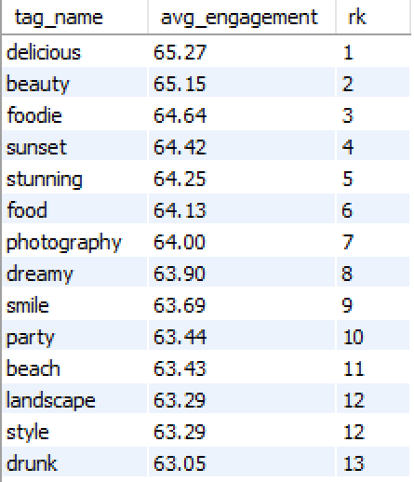
Insights:

- ‘delicious’ is the highest-engagement hashtag with an average engagement of 65.27 per post.
- Hashtags like ‘beauty’, ‘foodie’, ‘sunset’, and ‘stunning’ also show very strong performance, each achieving average engagement above 64.
- High-engagement hashtags primarily belong to food, beauty, travel, and aesthetic content categories.
- Emotion-driven hashtags such as ‘dreamy’, ‘smile’, and ‘happy’ also demonstrate strong user interaction, indicating users resonate with positive and visually appealing content.

Suggestions:
- Prioritize content creation in high-engagement categories such as food, beauty, travel, and aesthetic visuals.
- Boost content that uses top-performing hashtags to increase reach and discoverability.
- Launch reels, challenges, or campaigns featuring hashtags like #delicious, #beauty, #foodie, and #sunset to leverage their high engagement potential.
- Target ad campaigns to users who frequently interact with these high-engagement hashtags for better results.
- Collaborate with creators who consistently use and perform well with these hashtags to enhance campaign impact.
- Encourage users and influencers to mix high-engagement broad hashtags with niche-specific hashtags to maximize visibility and relevance.

- Are there any patterns or trends in user engagement based on demographics (age, location, gender) or posting times? How can these insights inform targeted marketing campaigns?

Approach:
- For the given dataset, unable to determine any patterns based on demographics (age, location, gender) or posting times as we do not have demographic data and the post time is the same for all the photos.

Insights:
- Though we do not have any insight from the given dataset, but normally, younger users (e.g., 18–24) may engage more with video content and viral trends and older users (e.g., 35+) may engage more with informational or community-based content
- Certain content types (e.g., beauty, sports, parenting) may have different engagement patterns across gender

Suggestions:
- Schedule ads/posts for 8–11 PM targeting Gen Z as the younger users are usually more active during that time.
Launch health campaigns targeted by gender and interest.

- Based on follower counts and engagement rates, which users would be ideal candidates for influencer marketing campaigns? How would you approach and collaborate with these influencers?

Approach:
- An influencer should have more followers than the normal users.
- And the engagement rate should also be high which shows that they are active.
- Query:
with activity_events as (
select user_id,1 as points from likes
union all
select user_id,3 as points from comments
union all
select user_id,5 as points from photos
),
user_activity as (
select
u.id as user_id,
u.username,
coalesce(sum(points) over(partition by u.id),0) as total_score,
sum(case when points=1 then 1 else 0 end) over(partition by u.id) as total_likes,
sum(case when points=3 then 1 else 0 end) over(partition by u.id) as total_comments,
sum(case when points=5 then 1 else 0 end) over(partition by u.id) as total_posts
from users u
left join activity_events ae
on u.id=ae.user_id
),
final_user_activity as (
select distinct
user_id,
username,
total_posts,
total_likes,
total_comments,
total_score
from user_activity
),
activity_user as (
select user_id,
username,
total_score as activity_score,
case
when total_score = 0 then "Inactive"
when total_score between 1 and 200 then "Low active"
when total_score between 201 and 400 then "moderate active"
else "high active"
end as activity_level
from final_user_activity
),
follower as (
select followee_id,
count(*) as followers
from follows
group by followee_id
)
select u.username,
f.followers,
u.activity_score,
u.activity_level
from activity_user u
join follower f
on u.user_id=f.followee_id;

end as activity_level
from final_user_activity
),
follower as (
select followee_id,
count(*) as followers
from follows
group by followee_id
)
select u.username,
f.followers,
u.activity_score,
u.activity_level
from activity_user u
join follower f
on u.user_id=f.followee_id;

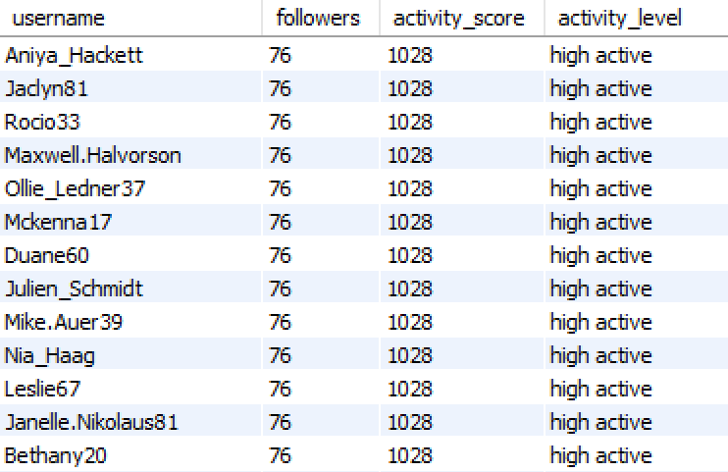

Insights:

- 13 users are found with high engagement and followers.
- They have 76 followers each and activity score of more than 1000 which includes number of photos, likes and comments.

Suggestions:

- We can approach the users/ influencers through DM or email and highlight what is in it for them (monetary, product gifts, visibility).
- Campaigns could include sponsored content, giveaways, or product reviews, and I would track performance using promo codes or UTM links to measure ROI.

- Based on user behavior and engagement data, how would you segment the user base for targeted marketing campaigns or personalized recommendations?

Approach:

- We can use the engagement/ active score as a standard to divide users into different activity segments (highly active, moderately active, low activity and inactive).
- I am using the below formula to determine the activity score:
activity_score = (weight_post × number_of_posts)
+ (weight_like × number_of_likes)
+ (weight_comment × number_of_comments).
- If we have demographic data, we can use that to create user segments based on age and location.
- Query-

with activity_events as (
select user_id,1 as points from likes
union all
select user_id,3 as points from comments
union all
select user_id,5 as points from photos
),
user_activity as (
select u.id as user_id ,u.username,
coalesce(sum(points) over(partition by u.id),0) as total_score,
sum(case when points=1 then 1 else 0 end) over(partition by u.id) as total_likes,
sum(case when points=3 then 1 else 0 end) over(partition by u.id) as total_comments,
sum(case when points=5 then 1 else 0 end) over(partition by u.id) as total_posts
from users u
left join activity_events ae
on u.id=ae.user_id ),
final_user_activity as (
select distinct
user_id,
username, total_posts, total_likes,
total_comments, total_score
from user_activity)
select *,
case
when total_score = 0 then "Inactive"
when total_score between 1 and 200 then "Low active"
when total_score between 201 and 400 then "moderate active"
else "high active"
end as activity_level
from final_user_activity;

Insights:

- We found that there are 13 highly active users, 64 moderately active users ,
- Low active and 13 inactive users.
- Highly active users who consistently post and engage are ideal for community building or ambassador programs.
- Users who have high follower count and high engagement score are ideal for influencer partnerships.

Suggestions:

- Send targeted campaigns to users based on their activity level and demographics.
- Suggest content based on previous interactions (e.g., topics, hashtags liked)
- Send push notifications or emails at users' peak active hours

- If data on ad campaigns (impressions, clicks, conversions) is available, how would you measure their effectiveness and optimize future campaigns?

Approach:

- We need to calculate performance KPIs like click-through rates (CTR), conversion rate (CVR), return on ad-spend (ROAS), etc.
- Need to perform analysis based in segments like platform, audience, time, etc.

Insights:

- Identify best performing campaigns.
- Spot underperforming areas.
- Analyze the audience behavior during specific time.

Suggestions:

- Increase spending on high performing campaigns.
- Schedule ads during high-engagement hours.
- Improve landing page by making them faster and mobile-friendly.

- How can you use user activity data to identify potential brand ambassadors or advocates who could help promote Instagram's initiatives or events?

Approach:

- Shortlist users based on consistency, content, and engagement.
- Use demographic data if available to identify potential ambassadors for a particular age group.

Insights:

- Micro-influencers often outperform macro accounts in engagement rate and authenticity.
- Highly engaged niche users are more likely to influence their tight-knit communities.

Suggestions:

- Reach out to users with consistent, high-quality content and loyal engagement.
- Create tiered ambassador program.
- Foster long term relationships by offering collaboration opportunities beyond one-time campaigns.

- How would you approach this problem, if the objective and subjective questions weren't given?

Approach:

- I would first understand the business goal as to what is the platform trying to achieve.
- Explore the provided dataset and identify key metrics.
- Create relevant questions and answer them using the provided data.

Insights:

- We would have insights regarding the user segmentation like active and inactive users.
- We would know the peak engagement hours.
- Trending interests by region, age, or gender.
- Identify rising influencers based on engagement trajectories.

Suggestions:

- Retarget dormant users with personalized content.
- Incentivize user referrals or participation in trends.
- Improve UX for underused but valuable sections.

- Assuming there's a "User_Interactions" table tracking user engagements, how can you update the "Engagement_Type" column to change all instances of "Like" to "Heart" to align with Instagram's terminology?
Approach:

- UPDATE User_Interactions: Targets the relevant table.
- SET Engagement_Type = 'Heart': Updates the value.
- WHERE Engagement_Type = 'Like': Ensures only the rows with "Like" are changed.
- Query:
update User_Interactions
set Engagement_Type = 'Heart'
where Engagement_Type = 'Like';
Insights:
- This ensures that we are aligning with Instagram’s terminology of Heart in the place of Like.
Suggestions:
- In this user interactions table, we can also have the various emojis the user used to react to posts.

